**Problem of the Week # 4**

**Birthday Candles**

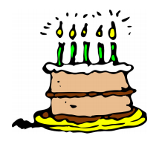

A birthday cake has a bunch of candles arranged in a growing pattern:

**red**, yellow; **red**, yellow, blue; **red**, yellow, blue, green; …

The pattern continues, adding pink, orange, purple, and white candles.

**How many total candles are on the cake if the last candle is white?**

**Show your work using pictures, numbers or words.**